Task 1: Develop a C program that demonstrates how a Linux operating system executes a command entered by a user that 1. Accept a Linux command as input. 2. Create a child process using fork(). 3. Execute the command in the child process using an appropriate exec() system call. 4. Allow the parent process to wait for the child using wait (). 5. Display the Process ID (PID) of both parent and child processes.
- Write a C code to create a process using fork() system call.
- Read the user input as shell command.
- Use a system call exec() to execute the shell command.
- Display the PIDs of parent and child processes.

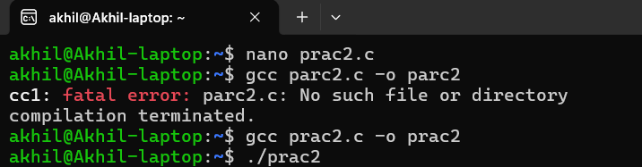
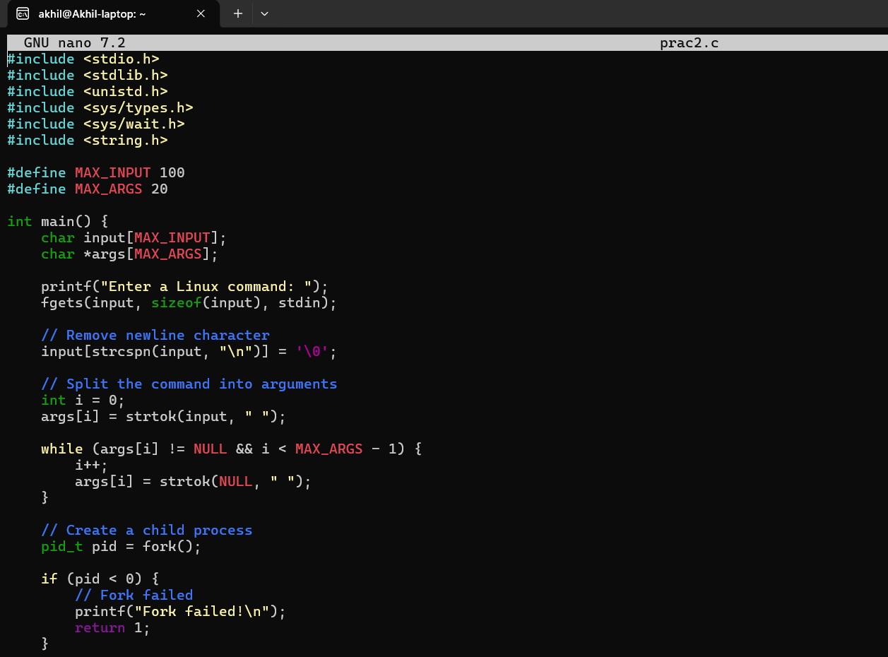

return 1;
}
else if (pid == 0) {
// Child process printf("\nChild Process\n");
printf("Child PID : %d\n", getpid()); printf("Parent PID: %d\n", getppid());

// Execute command execvp(args[0], args);

// Executes only if exec fails perror("Command execution failed"); exit(1);
}
else {
// Parent process printf("\nParent Process\n");
printf("Parent PID: %d\n", getpid()); printf("Child PID : %d\n", pid);
}
}

1)Then press ctrl+oenter ctrl+x2)then gcc filename.c -o filename

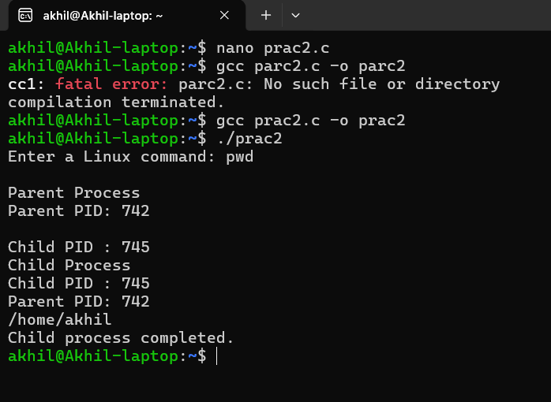
- then ./filename

akhil@Akhil-laptop: nano parc2.c
akhil@Akhil-laptop:~# gcc prace2.c -o prac2 akhil@Akhil-laptop:~# ./prac2
Enter a Linux command:

- enter the linux command

akhil@Akhil-laptop./prac2 Enter a Linux command: ls
Parent Process

Child Process

Parent PID: | 474
Child PID : | 477
Child PID : | 477
Parent PID: | 474
Dashboard | LICENSE | OSSP | Task1 | Task1.c.save | include shopping.c | skill
src

Child process completed.
Dashboard.c Makefile README.md Task1.c filename.c
shopping shopping.c.save skill.c
Child process completed.
balaji@BalajiPatil:~#

Task 2
Using Linux terminal commands (uname, lscpu, ps, top), investigate the relationship between hardware resources and operating system services. Prepare a report explaining how the OS abstracts CPU, memory, storage, and I/O devices.
An operating system is system software that controls all the hardware and software resources of a computer. Users do not communicate directly with the hardware. Instead, the operating system acts as a bridge between the user, applications, and the hardware
Linux Commands Used

uname
The uname command is used to display information about the Linux operating system. It provides details such as the operating system name, kernel version, machine architecture, and hostname. This command helps us identify the system on which Linux is running.
balaji@BalajiPatil:~# uname Linux
balaji@BalajiPatil:~#

lscpu
The lscpu command displays detailed information about the processor. It shows the CPU model, number of cores, number of threads, CPU architecture, and processor speed. This information helps us understand the hardware capabilities of the computer.
balaji@BalajiPatil:~# lscpu
Architecture:
CPU op-mode(s): Address sizes: Byte Order:
CPU(s):
x86_64
32-bit, 64-bit
39 bits physical, 48 bits virtual Little Endian
12

On-line CPU(s) list:
Vendor ID: Model name:
CPU family: Model:
Thread(s) per core: Core(s) per socket: Socket(s): Stepping:
BogoMIPS:
Flags:
0-11
GenuineIntel
12th Gen Intel(R) Core(TM) i5-1235U 6
154
2
6
1
4
4992.00
fpu vme de pse tsc msr pae mce cx8 apic sep mtrr pge mca cmov pat
pse36 clflush mmx fxsr sse sse2 ss ht syscall nx pdpe1gb rdtscp lm constant_tsc rep_good
nopl xtopology tsc_reliable nonstop_tsc cpuid tsc_known_freq pni pclmulqdq vmx sse3 fma cx16 pcid sse4_1 sse4_2 x2apic movbe popcnt tsc_deadline_timer aes xsave avx f16c rdrand hypervisor lahf_lm abm 3dnowprefetch ssbd ibrs ibpb stibp ibrs_enhanced tpr_shadow ept vpid ept_ad fsgsbase tsc_adjust bmi1 avx2 smep bmi2 erms invpcid rdseed adx smap clflushopt clwb sha_ni xsaveopt xsavec xgetbv1 xsaves avx_vnni vnmi umip waitpkg gfni vaes vpclmulqdq rdpid movdiri movdir64b fsrm md_clear serialize ibt flush_l1d arch_capabilities
Virtualization features:
Virtualization:
Hypervisor vendor: Virtualization type:
Caches (sum of all): L1d:
VT-x
Microsoft full
288 KiB (6 instances)

ps
The ps command lists the processes that are currently running in the system. It displays the Process ID (PID), Parent Process ID (PPID), user name, and the command associated with each process. This command is useful for monitoring and managing processes.

balaji@BalajiPatil:~# ps
PID TTY TIME CMD
435 pts/0 00:00:00 bash
503 pts/0 00:00:00 ps balaji@BalajiPatil:~#

top
The top command provides a real-time view of the system's performance. It continuously displays CPU usage, memory usage, running processes, and system load. It is commonly used to identify programs that consume a large amount of system resources.

top - 05:44:46 up 11 min, 1 user, load average: 0.00, 0.00, 0.00
Tasks: 22 total, 1 running, 21 sleeping, 0 stopped, 0 zombie
%Cpu(s): 0.0 us, 0.0 sy, 0.0 ni,100.0 id, 0.0 wa, 0.0 hi, 0.0 si, 0.0 st

MiB | Mem : |  | 7804.6 total, |  |  | 7276.2 | free, | 522.0 |  | used, | 156.4 |  | buff/cache
MiB | Swap: |  | 2048.0 total, |  |  | 2048.0 | free, | 0.0 |  | used, | 7282.7 |  | avail | Mem
PID |  | USER |  | PR | NI | VIRT | RES | SHR | S | %CPU | %MEM | TIME+ |  | COMMAND
1 |  | root |  | 20 | 0 | 21532 | 13044 | 9724 | S | 0.0 | 0.2 | 0:00.53 |  | systemd
2 |  | root |  | 20 | 0 | 3180 | 2200 | 2072 | S | 0.0 | 0.0 | 0:00.01 |  | init-systemd(Ub
6 |  | root |  | 20 | 0 | 3196 | 2128 | 2008 | S | 0.0 | 0.0 | 0:00.00 |  | init
52 |  | root |  | 19 | -1 | 50448 | 16000 | 14840 | S | 0.0 | 0.2 | 0:00.29 |  | systemd-journal
97 |  | root |  | 20 | 0 | 25380 | 6788 | 5168 | S | 0.0 | 0.1 | 0:00.26 |  | systemd-udevd
165 |  | systemd+ |  | 20 | 0 | 21344 | 13232 | 11108 | S | 0.0 | 0.2 | 0:00.10 |  | systemd-resolve
166 |  | systemd+ |  | 20 | 0 | 91036 | 7988 | 7020 | S | 0.0 | 0.1 | 0:00.08 |  | systemd-timesyn
172 |  | root |  | 20 | 0 | 4244 | 2680 | 2428 | S | 0.0 | 0.0 | 0:00.00 |  | cron
173 |  | message+ |  | 20 | 0 | 9528 | 5308 | 4612 | S | 0.0 | 0.1 | 0:00.06 |  | dbus-daemon
180 |  | root |  | 20 | 0 | 17980 | 8856 | 7812 | S | 0.0 | 0.1 | 0:00.05 |  | systemd-logind
186 |  | root |  | 20 | 0 | 1756104 | 13112 | 10888 | S | 0.0 | 0.2 | 0:00.10 |  | wsl-pro-service
193 |  | syslog |  | 20 | 0 | 222516 | 5988 | 4624 | S | 0.0 | 0.1 | 0:00.07 |  | rsyslogd
201 |  | root |  | 20 | 0 | 3124 | 1976 | 1836 | S | 0.0 | 0.0 | 0:00.00 |  | agetty
213 |  | root |  | 20 | 0 | 107032 | 23288 | 13836 | S | 0.0 | 0.3 | 0:00.10 |  | unattended-upgr
300 |  | root |  | 20 | 0 | 6672 | 4496 | 3728 | S | 0.0 | 0.1 | 0:00.01 |  | login
343 |  | root |  | 20 | 0 | 20320 | 11580 | 9452 | S | 0.0 | 0.1 | 0:00.09 |  | systemd
344 |  | root |  | 20 | 0 | 21168 | 3516 | 1804 | S | 0.0 | 0.0 | 0:00.00 |  | (sd-pam)
368 |  | root |  | 20 | 0 | 6080 | 5276 | 3652 | S | 0.0 | 0.1 | 0:00.00 |  | bash
430 |  | root |  | 20 | 0 | 3188 | 1112 | 980 | S | 0.0 | 0.0 | 0:00.00 |  | SessionLeader
432 |  | root |  | 20 | 0 | 3204 | 1252 | 1108 | S | 0.0 | 0.0 | 0:00.07 |  | Relay(435)
435 |  | root |  | 20 | 0 | 6080 | 5352 | 3672 | S | 0.0 | 0.1 | 0:00.03 |  | bash
504 |  | root |  | 20 | 0 | 9280 | 5376 | 3224 | R | 0.0 | 0.1 | 0:00.00 |  | top

